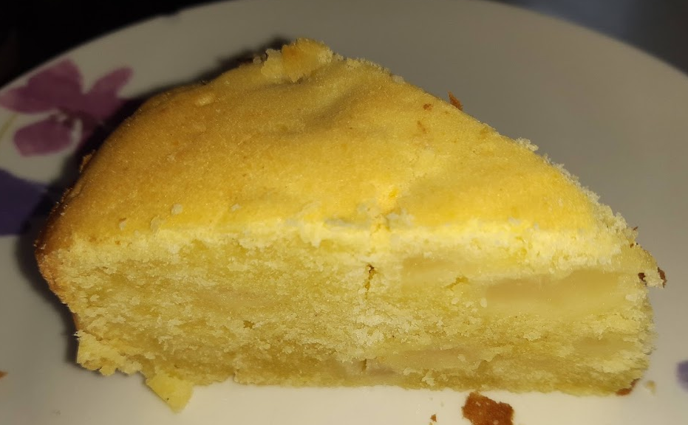

Gluten Free Apple and Pear Cake
Recipe shared courtesy of Rebecca Kibbler
Ingredients
-Gluten free plain flour
-Caster Sugar
-2 Eggs
-Margarine
-Unsweetened tinned apples
-Tinned pears in refined juice

METHOD
Mix 8 tablespoons of flour and 8 tablespoons of caster sugar together in a mixing bowel.
Add 2 medium sized eggs and 4 tablespoons of margarine to your dry cake mix, and mix well until all your ingredients are combined and the mixture is a smooth ‘dropping’ consistency.
If the mixture is too dry gently add the refined juice from the pears to the mixture in increments.
Finely chop your tinned apples and pears and add them to your mixture. (If you prefer larger pieces of fruit in your cake don’t chop so finely).
Mix everything together well. If the fruit makes your mixture too wet add a tablespoon of flour at a time until you achieve the right consistency.
Bake in the oven until cooked.

