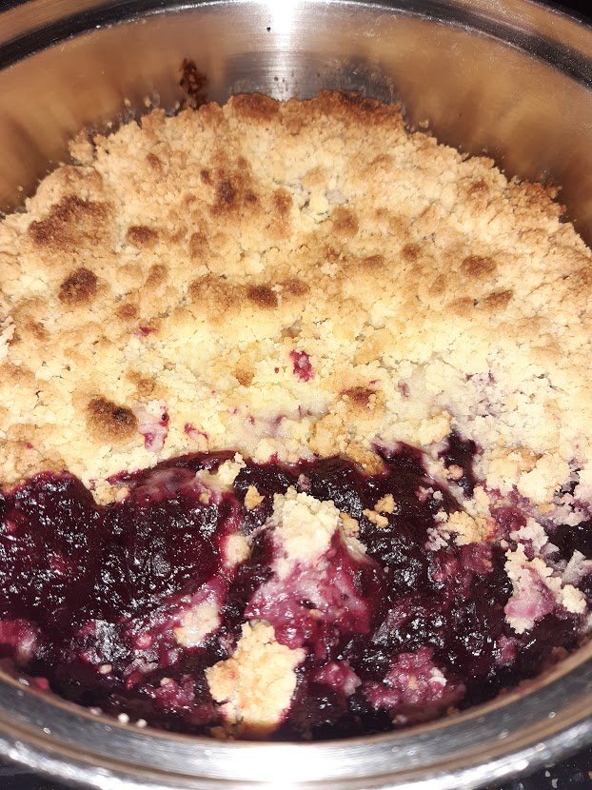

Gluten Free Blackcurrent Crumble
Recipe shared courtesy of Rebecca Kibbler
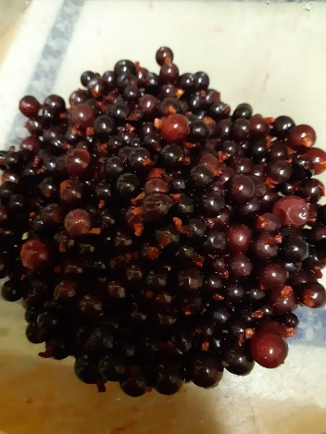
This recipe was made using fresh blackcurrents from my garden, but you can use fresh, tinned or frozen fruit in your cumble (if using frozen defrost the fruit thoroughly first.)
Ingredients
-Blackcurrents
-5 Brambley Cooking Apples
-Caster Sugar
-Gluten Free Plain Flour
-Butter

METHOD
Start by stewing your fruit! Peel and chop your 5 cooking apples, and add them to your blackcurrents in a sieve. Wash your fruit thoroughly and pour into a pan. Add 2 teaspoons of water and 8 tablespoons of caster sugar to your fruit. Reduce on a low heat on the hob until the fruit is the consistency of jam. Keep an eye to make sure that your fruit doesn’t boil dry and burn.
To make your crumble add 4 tablespoons of butter, 6 tablespoons of caster sugar and 8 tablespoons of gluten free pain flour into a mixing bowl. Rub the ingredients together gently between your fingers until the mixture is the consistency of bread crumbs.
Pour the stewed fruit into a pan and sprinkle the crumble mix on top. Cook on a medium heat in the centre of the oven for approximately 30 minutes or until the crumble topping is golden brown. Cooking times may vary depending on the type of your oven.
I suggest serving with cream, custard, or ice cream. Enjoy!

