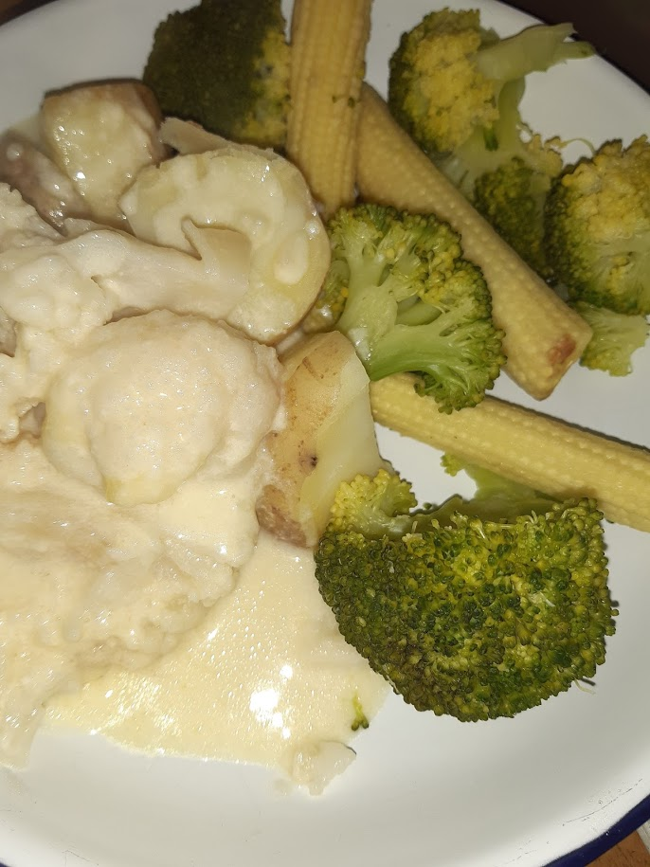

Gluten Free Cauliflower Cheese
Recipe shared courtesy of Rebecca Kibbler

Ingredients
-1 Large Cauliflower
-2 Medium Potatoes
-Whole Milk
-Mature Cheese
-Salt
-Mustard Powder
Step 1 – Chop and bake your Cauliflower in the oven until soft but not mushy.
Step 2 – Peel and chop 2 medium sized potatoes potatoes, and boil, then grate your cheese.
Step 3 – Blend potatoes with a food blender until there are no lumps (strain if needed).
Step 4 – Add blended potatoes to a saucepan and gradually add milk to required amount whilst stirring. Note – potatoes will not thicken a sauce in the same way as flour and so the more sauce you are making the more potatoes you need to thicken it.
Step 5 – Add three quarters of your grated cheese, 1 teaspoon of mustard powder, salt and any other desired seasonings to your sauce.
Step 6 – Pour your sauce over your baked cauliflower, sprinkle the rest of the grated cheese on top, and place back in the oven to bake.
SERVE AS A SIDE, EAT & ENJOY

