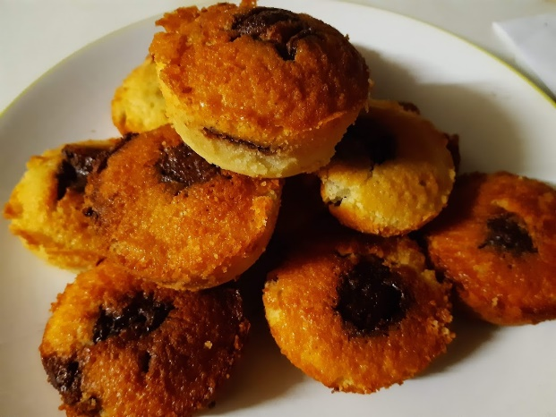

Gluten Free Giant Choccy Button Cake
Recipe shared courtesy of Rebecca Kibbler
Ingredients
-8 tbls Gluten Free Plain Flour
-8 tbls Caster Sugar
-4 tbls Butter
-2 eggs
-Whole Milk
-Giant Chocolate Buttons to personal taste
Method
- Mix your dry ingredients, 8 tablespoons of flour and 8 tablespoons of sugar together in a mixing bowl.
- Add your wet ingredients – 2 eggs and 4 tablespoons of butter – to your dry ingredients. If your butter is very hard partially melt it in a microwave to soften it before adding it to the mixture.
- Mix everything together well, making sure to incorporate all of the dry mixture. Your cake batter should be a dropping consistency. If your batter is still too thick add a small amount of milk a bit at a time until your batter reaches the correct consistency.
- Add your chocolate buttons to your personal taste and mix in well.
- Pour your batter evenly into individual cake cases and top with a chocolate button for decoration.
- Bake in the middle of the oven, until golden brown and cooked through. Baking time varies between ovens. Check on your cakes every 5-10 minutes to make sure they’re not burning.
- Once cooked take out and leave to cool. Once cooled turn cakes out onto a plate and wait to go cold before serving, or serve warm if you prefer your cakes to melt in the middle.

