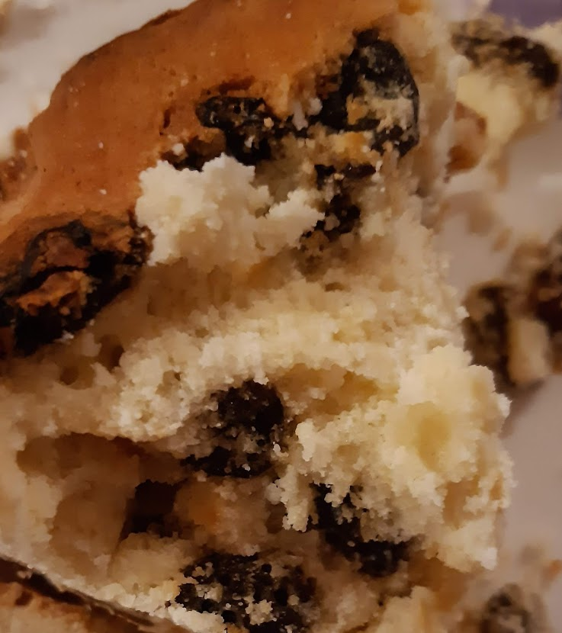

Gluten Free Raison Cake
Recipe shared courtesy of Rebecca Kibbler
Ingredients
-8 Tbls Gluten Free Flour
-8 Tbls Sugar
-4 Tbls Butter
-2 Eggs
-Raisons
METHOD
Add your flour and your sugar to your mixing bowl, and mix together before adding your butter and your 2 eggs. If the mixture is too dry you can add a small amount of milk until your cake mixture becomes a ‘dropping’ consistency.
Finally add your raisons to taste.
Place in the centre of the oven on a medium temperature for 30 minutes and check back regularly to make sure it isn’t burning.
Once the cake is baked, wait for it to cool, then serve & enjoy!

