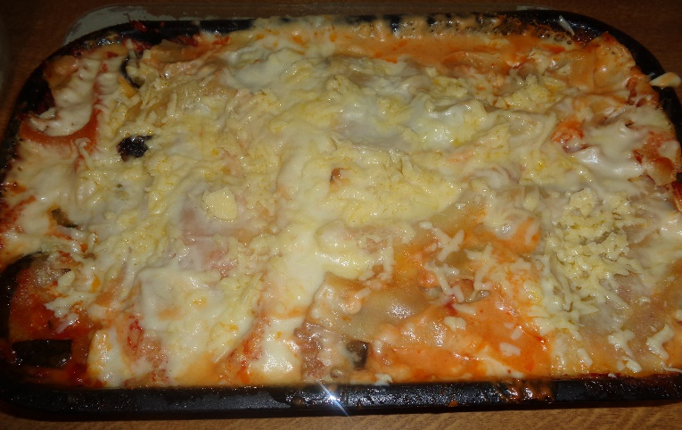

Gluten Free Roast Vegetable Lasagne
Recipe shared courtesy of Rebecca Kibbler
Ingredients
-Your choice of fresh Vegetables for roasting
-Cooking or Vegetable Oil
-Gluten Free Lasagne Sheets
-1kg of tinned tomatoes or passata
-Salt to taste
-Sugar to taste
-Gluten free plain flour
-Butter
-Whole Milk
-Mature Cheddar Cheese
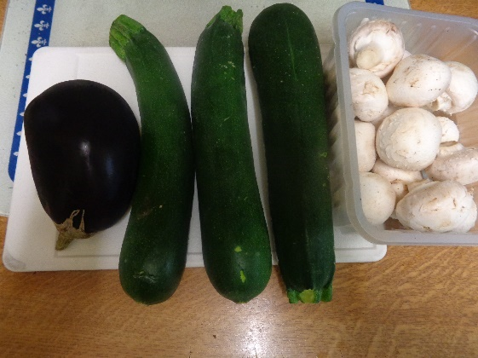
STEP 1
Start by selecting your vegetables. I have chosen:
Courgettes
Aubergine
Mushrooms
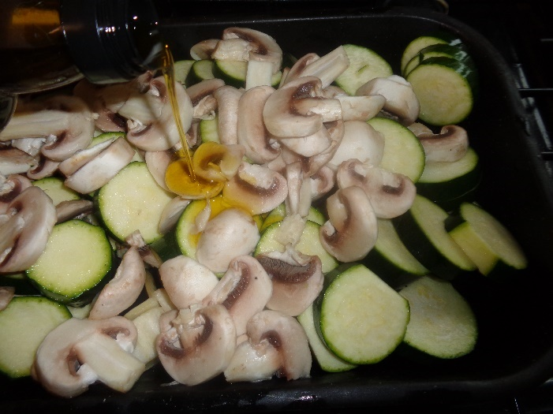
Slice the vegetables into a
roasting tray and cover with
cooking/vegetable oil. Here I have
chosen olive oil.
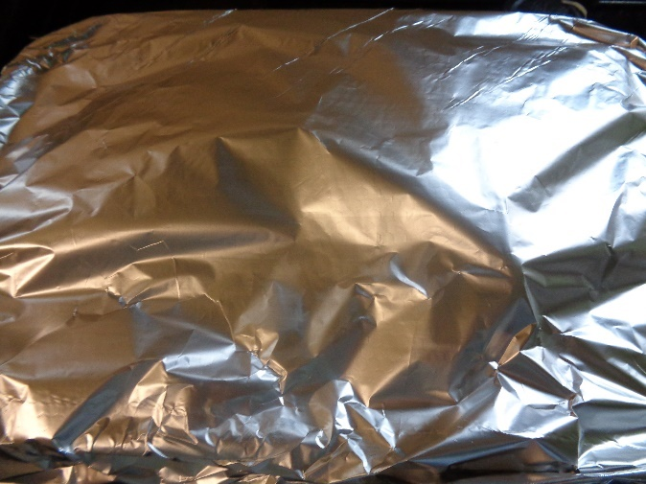
Cover with silver foil – shiny side in will help the vegetables to cook quicker – and cook in the oven until soft.

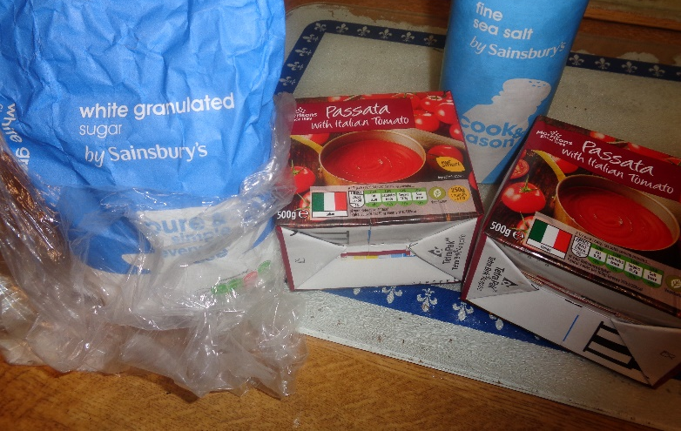
STEP 2
To make the tomato sauce pour the passata into a large jug or saucepan. If using tinned tomatoes use a blender first to get rid of any large lumps. Add salt and sugar to taste. If your tomatoes are bitter add more sugar slowly – one teaspoon at a time. Mix well.
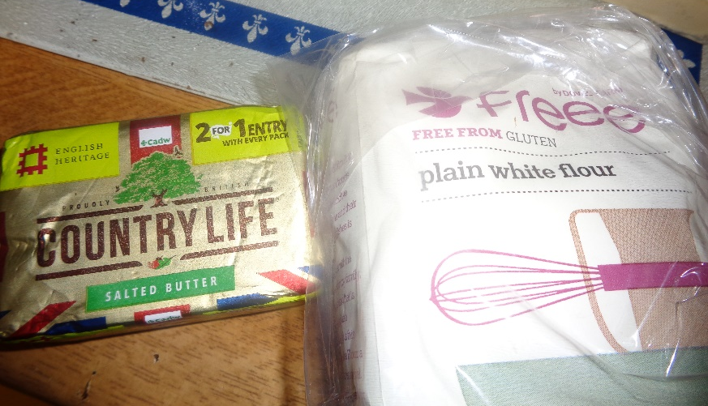
STEP 3
Start by making the roux for your white sauce. Melt 2 tablespoons of butter in a saucepan. When the butter is fully melted remove the pan from the heat and add 2 tablespoons of gluten free plain flour.
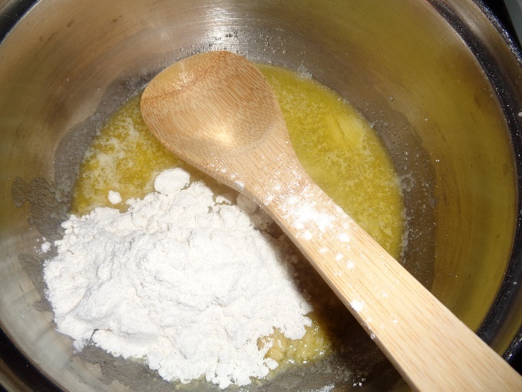
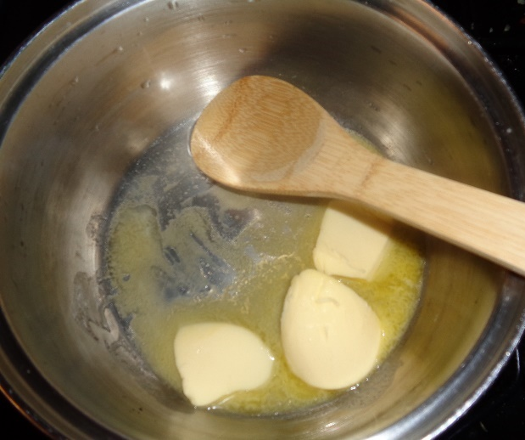

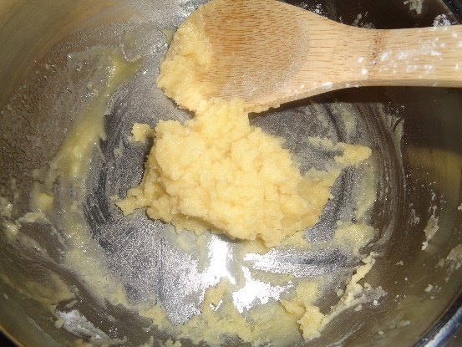
Mix the flour and melted butter together until it forms a thick paste. This is your roux.

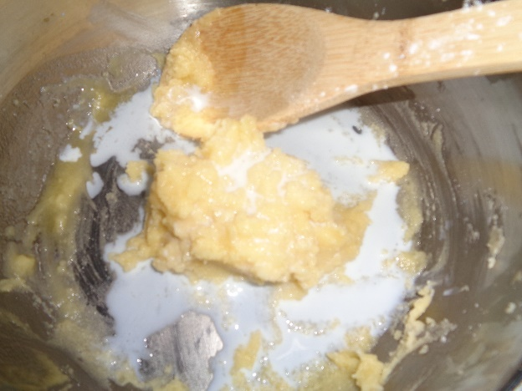
To make your white sauce gradually add your milk to the roux a small amount at a time, mixing it well. Make sure not to add too much milk in one go otherwise your mixture will split.
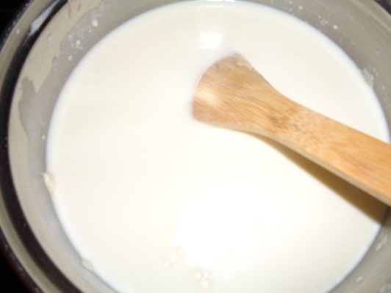
Once your mixture reaches the consistency of a thick paste you can then add more milk to the mixture to make your sauce. Mix well.
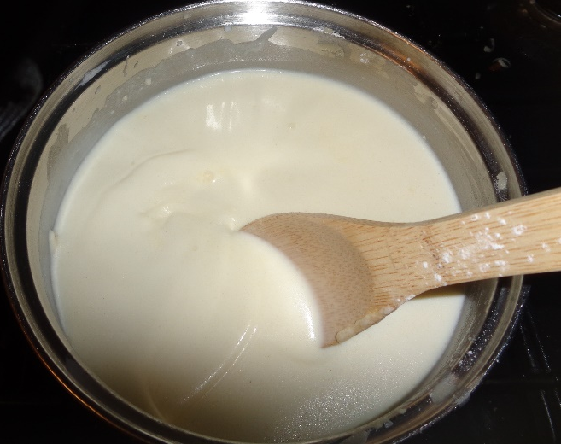
Put your sauce back on the hob and heat at a medium temperature. Stir constantly to avoid lumps developing as the flour cooks, until your sauce starts to thicken. This will take a few minutes. Once the sauce has fully thickened you can then stop stirring and leave the mixture to stand on the heat for a few seconds until it starts to bubble.
If your sauce looks too thick take your saucepan off the heat and add a small amount of milk, mixing it in well. Just as when you were adding your milk to your roux add a little milk at a time and make sure not to add too much at once as this will cause your sauce to split.
Add a small pinch of salt and grated cheese to taste. Stir your sauce well until all the cheese has melted.

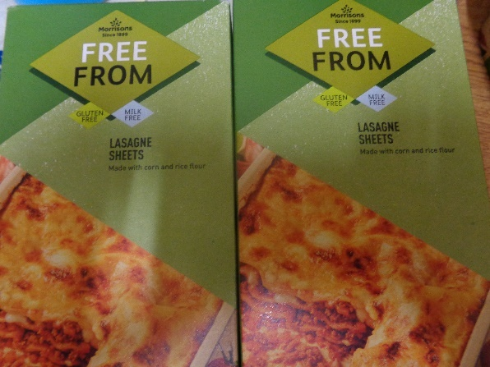
STEP 4
Assemble your lasagne, adding layers of tomato sauce and vegetables between pasta sheets. Make sure that your pasta sheets are well covered with sauce to prevent them from going dry during cooking.
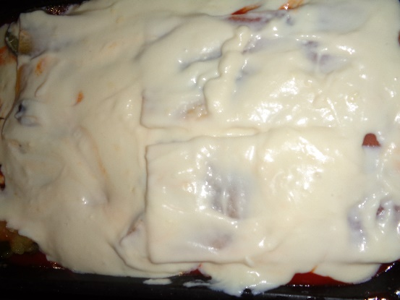
Top off your lasagne with your white sauce. Cover with baking paper and silver foil and place in the oven on a medium heat. When your lasagne is cooked take out and add grated cheese to taste on the top!

SERVE AND ENJOY!
