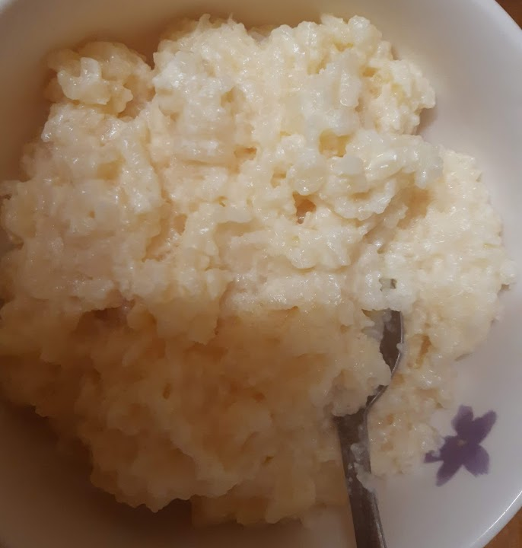

Simple Rice Pudding
Recipe shared courtesy of Rebecca Kibbler
Ingredients
-2 Pints Whole Milk
-1 Mug of Pudding Rice
-1 Teaspoon of Butter
-8 Tablespoons of Caster Sugar
METHOD
Please note that I do not use weights and measurements when I am cooking and baking, I use cups and spoons and do the rest of it by eye, so this method is an approximation only, and you may like to tweek it to your own tastes. Bare in mind that you can add more milk to the pudding during the cooking process to make it thinner but you can’t add more rice to thicken it, so it is always better to have a slightly higher ratio of rice to milk than milk to rice. Rice is naturally gluten free but if, like me, you are following a gluten free diet please check the label before buying as some rice is handled in a factory which also processes gluten containing ingredients, and some manufacturing methods render it unsuitable. Where this is the case it should be stated on the packet!
Pour 1 mug of pudding rice into a sieve and rinse under the tap. When all the rice has been thoroughly washed pour it into a pan and add 2 pints of whole milk, and 8 tablespoons of caster sugar. Mix everything together, and spoon in one teaspoon of butter on top.
Cover with silver foil (shiny side in) and cook on a low heat in the middle of the oven. Cooking times will vary depending on the type of oven you have, but I cooked mine for 3 hours until the rice was soft and the milk had been absorbed.
SERVE & ENJOY!

