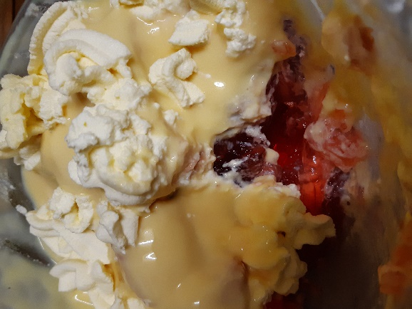

The ‘There’s No Way To Take A Good Photo of a Trifle’ Trifle (Gluten Free)
Method shared courtesy of Rebecca Kibbler
Ingredients
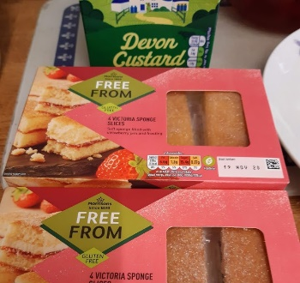
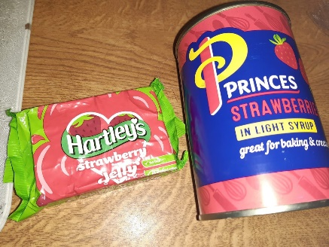
-Strawberry Jelly Mix
-Tinned Strawberries in syrup (or fresh if preferred, but tinned will preserve longer and are often sweeter)
-Sponge Cake (homemade or shop brought)
-Custard
-Double Cream for whipping
This is more of method than a recipe and is really simple to follow. It is just a case of assembling the pre-made ingredients together and is the perfect answer if you would like a really simple desert but don’t have time to spend baking or making one from complete scratch. If you would like to have a more homemade taste to your finished trifle you can make your own sponge cake and use fresh rather than tinned strawberries, but if using fresh strawberries out of season they may be more bitter.
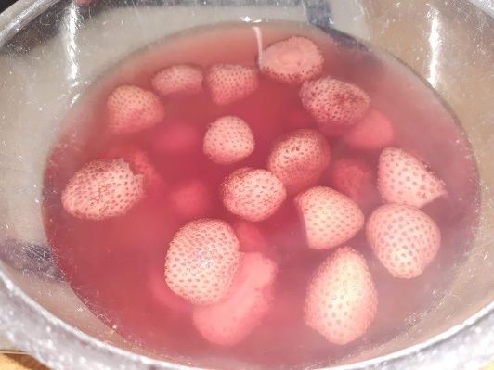
STEP 1: Dissolve the Strawberry Jelly in boiling water until there are no solid lumps of gelatine left. Stir well and pour into your bowel over your strawberries. This would also normally be where you would add your sponge cake to make a traditional trifle. Wait until cool, cover and place in the fridge to set. To give this enough time to completely set it is best to do this overnight.

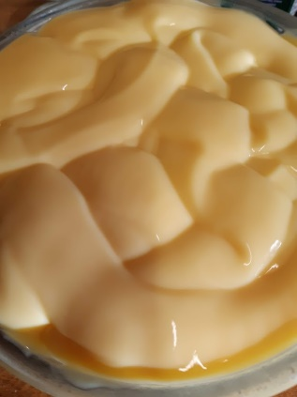
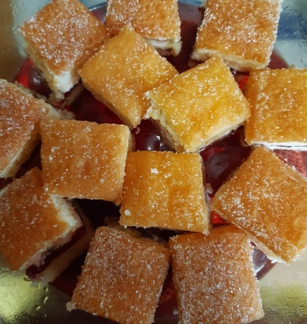
STEP 2: This is where I chose to add my sponge cake. Due to gluten free having a generally softer and more brittle consistency than regular sponge cake I didn’t want it to turn to mush inside the jelly and so decided to add it on top. When your jelly has completely set pour over custard, recover and place back in the fridge for a couple of hours.

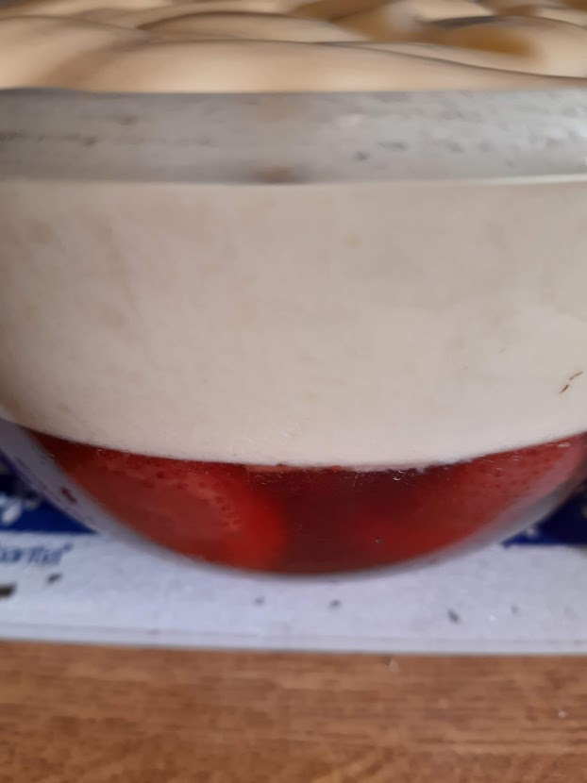

STEP 3: Whip double cream. To do this make sure you have a large enough bowel, and using either a whisk or a fork whisk quickly and constantly until cream starts to thicken and form stiff peaks. This could take a few minutes! If you have one I would recommend using an electric whisk to do this!
STEP 4: Add your cream to the top of your trifle. You can do this by either spooning and spreading it on carefully, or if you have a piping bag pipe it on for a neater appearance.
SERVE & ENJOY!

